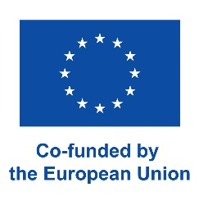 | PERSONAL DATA  ERASMUS+ PROGRAMME  STUDY EXCHANGE | 

PERSONAL DATA
SURNAME: |  | FIRST NAME: |  |  |  |  |  | Date of birth:
Nationality: |  |  | Index numer:
email address: |  |  | phone number:
Contact data in case of emergency: (relative, phone number)

PREVIOUS PARTICIPATION IN ERASMUS PROGARMME
Have you taken part In Erasmus Programme at the same study level?
Study: | Period of stay: from till |  |  |  |  | Study cycle:
Training: | Period of stay: from till |  |  |  |  | Study cycle:
FACULTY DATA:
Name of the Faculty at WULS - SGGW
Study cycle during Erasmus exchange(BSc, Eng. or MSc): |  |  |  |  | Field of study:
ERASMUS NOMINATION
University which you have been recruited to: |  |  |  | Country: |  |  | Language of instruction for Erasmus students
semester :

Wypełnia Biuro Współpracy Międzynarodowej

Uwagi

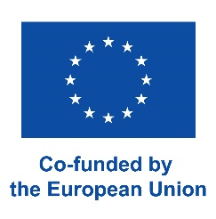 | Program Erasmus+ - Szkolnictwo Wyższe  Akcja 1 - Mobilność studentów i pracowników uczelni | 

Information clause on the protection of personal data

Pursuant to Art. 13 (1, 2) of Regulation (EU) 2016/679 of the European Parliament and of the Council of 27 April 2016 on the free movement of such data and repealing Directive 95/46/EC (hereinafter referred to as "GDPR"), it is informed that:
- The Administrator of personal data is the Warsaw University of Life Sciences, ul. Nowoursynowska 166, 02-787 Warsaw, hereinafter referred to as the "Administrator";
- The Administrator has appointed a Data Protection Officer who can be contacted in all matters related to the processing of personal data and the exercise of rights by data subjects under the GDPR at the email address: iod@sggw.edu.pl;
- Your personal data obtained in connection with the implementation of mobility in the Erasmus+ exchange programme will be processed on the basis of: Art. 6 (1b) GDPR - in order to implement the mobility and legally justified interests by the Administrator, Art. 6 (1c) GDPR - in order to fulfil the legal obligations incumbent on the Administrator;
- The recipients of your data will be entities and bodies to which the Administrator is obliged or authorized to provide personal data on the basis of generally applicable provisions of law, and entities to which the Administrator entrusts its processing on the basis of an appropriate agreement in connection with the services provided by the above-mentioned entity in favour of the Administrator, and guaranteeing the proper implementation of the objectives referred to in point c) above;
- Personal data will be kept for the duration of the Erasmus+ project under which the given educational mobility takes place, and after that time for the period and to the extent required by generally applicable law or to secure and pursue possible claims and to defend against such claims;
- Data subjects have the right to access the above-mentioned personal data, rectify it, delete or limit processing and the right to object to data processing;
- Data subjects have the right to lodge a complaint with the supervisory body, in the territory of the Republic of Poland this body is the President of the Personal Data Protection Office;
- Providing your personal data is voluntary but necessary for the mobility in the Erasmus+ programme;
- Your personal data will not be subject to automated decision making and will not be profiled.

………………………………………………
Date and legible signature

